PHP Web Shell Detection Using Machine Learning

- Introduction
Web shells are malicious scripts, commonly written in PHP there is a lot of shells like jsp ,python , perl etc … that give attackers remote command execution on a compromised web server. These scripts are a serious security risk, allowing unauthorized access and enabling attackers to control systems, steal data and escalate privileges.
Current signature-based detection techniques are unable to detect new or obfuscated web shells. Therefore, this project aims to develop a machine learning-based approach for detecting malicious PHP web shells by analyzing their source code.

2. Objective
The main objectives of this project are:
- To build a system that classifies PHP files as benign or malicious
- To apply machine learning techniques for web shell detection
- To evaluate the effectiveness of the model using standard metrics
- To generate an automated HTML report for results visualization

- Dataset
The dataset used in this project consists of:
- Malicious files: Real-world PHP web shells collected from public repositories
- Benign files: Normal PHP scripts created for comparison
The dataset structure:
dataset/
├── malicious/
└── benign/
Total samples used:
- Malicious files: ~119
- Benign files: ~51
- Total: 170 samples

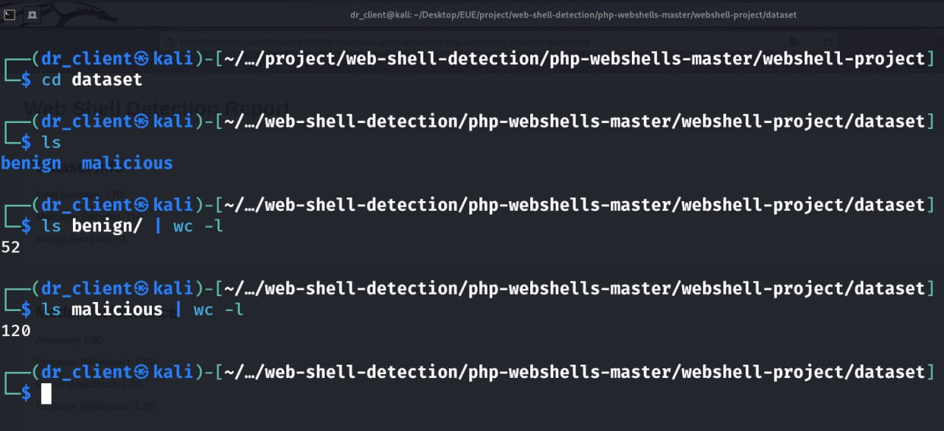

4. Methodology
4.1 Data Collection
Malicious PHP web shells were collected from publicly available sources. Benign PHP files were manually created to simulate normal application behavior.

4.2 Data Preprocessing
Each PHP file was read as raw text. No manual feature engineering was applied, allowing the model to learn patterns automatically.

4.3 Feature Extraction
Text data was converted into numerical features using:
- TF-IDF (Term Frequency – Inverse Document Frequency)
This technique transforms code into a vector representation based on word importance.

4.4 Model Selection
The model used:
- Random Forest Classifier
Reasons:
- Handles high-dimensional data well
- Robust against overfitting
- Suitable for classification tasks

4.5 Training and Testing
- Dataset split: 80% training / 20% testing
- Model trained on labeled data
- Predictions evaluated on unseen test data

5. Results
The model achieved the following performance:
- Accuracy: 97%
- Precision (Malicious): 1.00
- Recall (Malicious): 0.95
- F1-Score: 0.98
Interpretation:
- The model correctly identifies most malicious files
- Very low false positives
- High reliability for web shell detection

6. Visualization
A confusion matrix was generated to visualize model performance:
- True Positives: Correctly detected web shells
- True Negatives: Correctly detected benign files
- False Positives: Benign files marked as malicious
- False Negatives: Missed web shells

7. System Output
The system produces:
- model.pkl → trained machine learning model
- vectorizer.pkl → feature extraction model
- confusion_matrix.png → performance visualization
- report.html → automated professional report

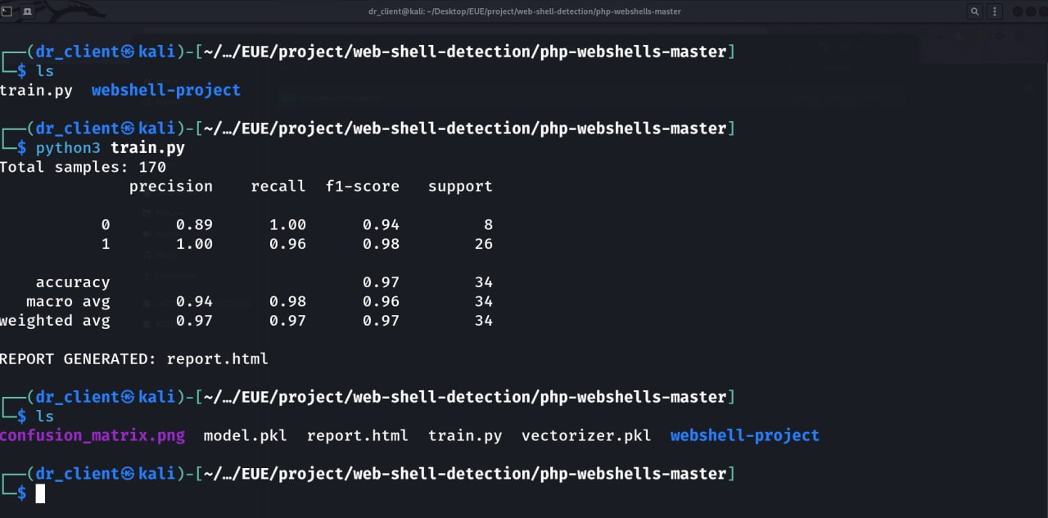

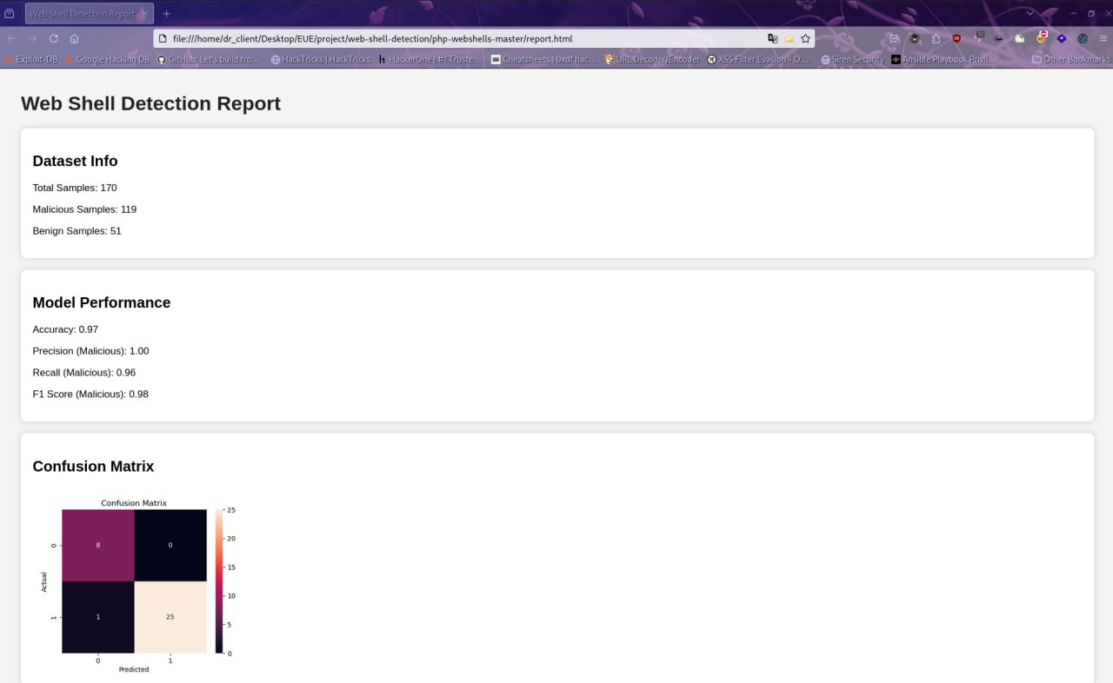

8. Discussion
The results demonstrate that machine learning can effectively detect PHP web shells based on code patterns.
Key observations:
- Malicious scripts often contain functions like:
  - eval()
  - exec()
  - system()
- TF-IDF successfully captures these patterns
- Random Forest provides strong classification performance
9.python code :

import os
import pandas as pd
import joblib
import seaborn as sns
import matplotlib.pyplot as plt

from sklearn.model_selection import train_test_split
from sklearn.feature_extraction.text import TfidfVectorizer
from sklearn.ensemble import RandomForestClassifier
from sklearn.metrics import classification_report, confusion_matrix

# ----------------------------
# LOAD DATA
# ----------------------------
def load_files(folder, label):
data, labels = [], []
for file in os.listdir(folder):
if file.endswith(".php"):
try:
with open(os.path.join(folder, file), "r", errors="ignore") as f:
data.append(f.read())
labels.append(label)
except:
continue
return data, labels

malicious_data, malicious_labels = load_files("/home/dr_client/Desktop/EUE/project/web-shell-detection/php-webshells-master/webshell-project/dataset/malicious", 1)
benign_data, benign_labels = load_files("/home/dr_client/Desktop/EUE/project/web-shell-detection/php-webshells-master/webshell-project/dataset/benign", 0)

X = malicious_data + benign_data
y = malicious_labels + benign_labels

print("Total samples:", len(X))

# ----------------------------
# VECTORIZE
# ----------------------------
vectorizer = TfidfVectorizer(max_features=3000)
X_vec = vectorizer.fit_transform(X)

# ----------------------------
# TRAIN
# ----------------------------
X_train, X_test, y_train, y_test = train_test_split(
X_vec, y, test_size=0.2, random_state=42
)

model = RandomForestClassifier(n_estimators=200)
model.fit(X_train, y_train)

# ----------------------------
# EVALUATION
# ----------------------------
y_pred = model.predict(X_test)

report = classification_report(y_test, y_pred, output_dict=True)
cm = confusion_matrix(y_test, y_pred)

print(classification_report(y_test, y_pred))

# ----------------------------
# SAVE MODEL
# ----------------------------
joblib.dump(model, "model.pkl")
joblib.dump(vectorizer, "vectorizer.pkl")

# ----------------------------
# CONFUSION MATRIX IMAGE
# ----------------------------
plt.figure(figsize=(5,4))
sns.heatmap(cm, annot=True, fmt="d")
plt.title("Confusion Matrix")
plt.xlabel("Predicted")
plt.ylabel("Actual")
plt.savefig("confusion_matrix.png")
plt.close()

# ----------------------------
# HTML REPORT GENERATOR
# ----------------------------
html = f"""
<html>
<head>
<title>Web Shell Detection Report</title>
<style>
body {{
font-family: Arial;
margin: 40px;
background-color: #f4f4f4;
}}
.box {{
background: white;
padding: 20px;
border-radius: 10px;
margin-bottom: 20px;
box-shadow: 0px 0px 10px #ccc;
}}
h1 {{
color: #222;
}}
</style>
</head>

<body>

<h1>Web Shell Detection Report</h1>

<div class="box">
<h2>Dataset Info</h2>
<p>Total Samples: {len(X)}</p>
<p>Malicious Samples: {len(malicious_data)}</p>
<p>Benign Samples: {len(benign_data)}</p>
</div>

<div class="box">
<h2>Model Performance</h2>
<p>Accuracy: {report['accuracy']:.2f}</p>
<p>Precision (Malicious): {report['1']['precision']:.2f}</p>
<p>Recall (Malicious): {report['1']['recall']:.2f}</p>
<p>F1 Score (Malicious): {report['1']['f1-score']:.2f}</p>
</div>

<div class="box">
<h2>Confusion Matrix</h2>
<img src="confusion_matrix.png" width="400">
</div>
</body>
</html>
"""

with open("report.html", "w") as f:
f.write(html)

print("REPORT GENERATED: report.html")

GitHub link :
https://github.com/aliwaleed899/Math/tree/main

